Acceptance Test for Upload database for custom BLAST search User Story
The user opens the main GUI.
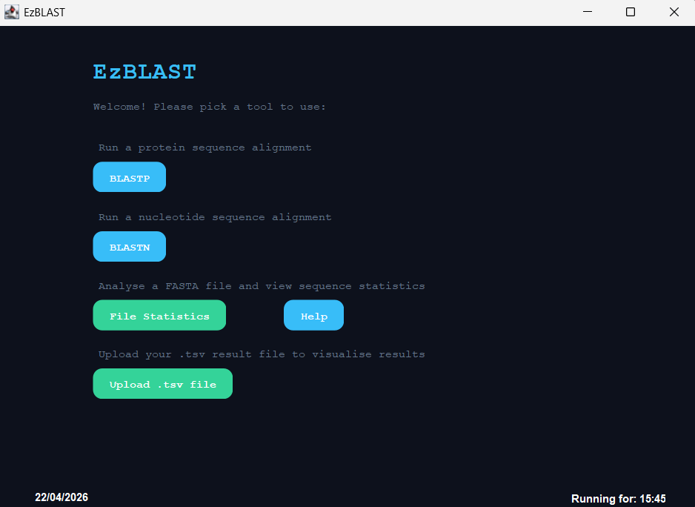
The navigates to BLAST and uploads their database and query sequence.
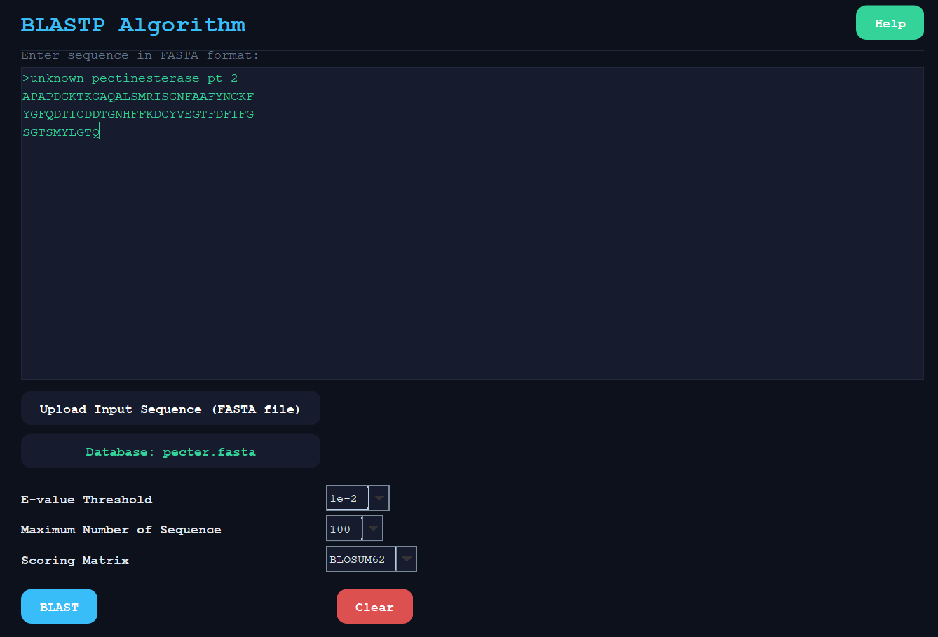

The user runs BLAST and an output is created with information about the matching sequences.
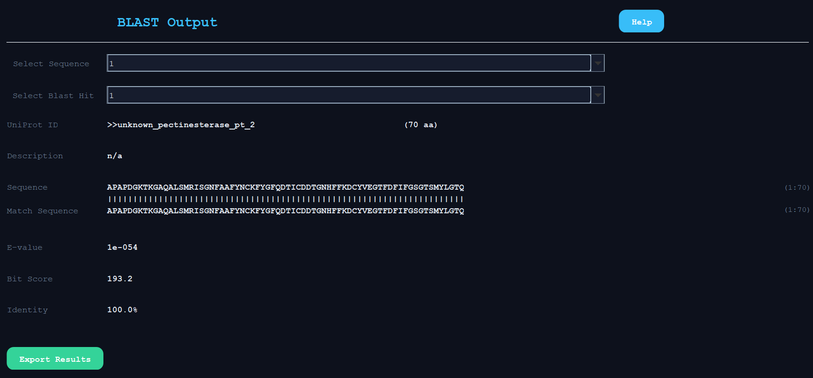
If the sequence doesn’t match the sequences in the database…
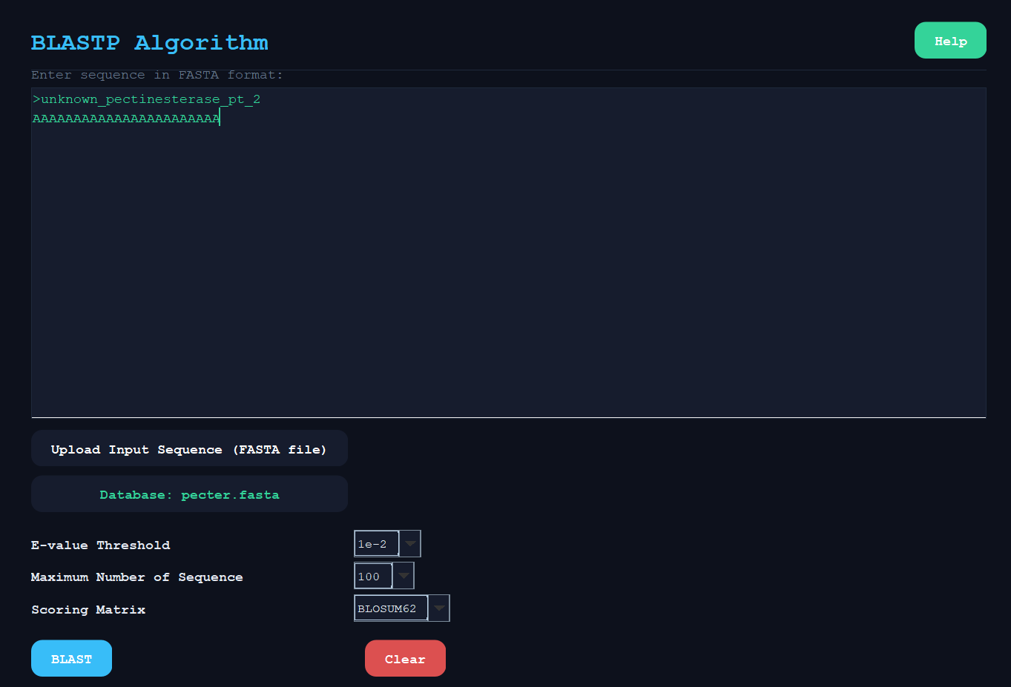

no useable output is formed.
